Stage 6 –Blow things up!
COURSE DESIGNER: John Royer / Outdoor Dynamics
SCORING: Comstock 30 rounds.
TARGETS: 15 cardboard targets, 2 steel targets
SCORED HITS: 2 Best hits per carboard will be scored.

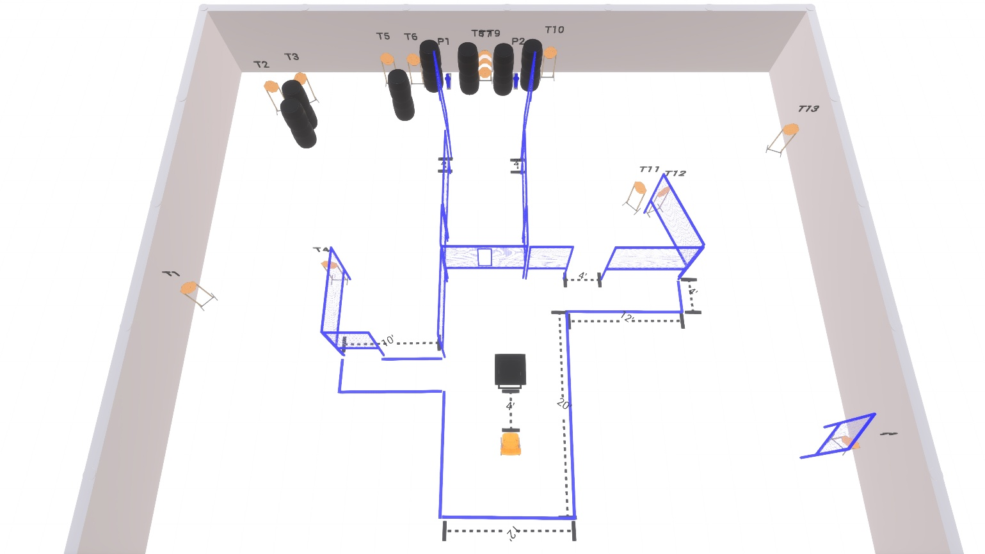

Written Stage Briefing:

Stage 6 – Blow things up! - is a 30 round, 150 point, Comstock Course. There are 14 cardboard targets and 2 steel targets.

Starting seated in chair with hands on top of head.
Firearm is unloaded and placed on table with muzzle pointing downrange.
ALL magazines to be used must be placed on table prior to the start signal.

On the audible start signal, engage targets from within the shooting area.

USPSA / NROI Range Commands:
- Make Ready
- Are you ready?
- Standby
- If finished, unload and show clear
- If clear, hammer down and holster (Handgun)
If clear, hammer down and flag (PCC)
If clear, cylinder closed and holster (Revolver)
- Range is clear

Setup Notes:
10 Single Wall Stands
4 Double Wall Stands
2 Triple Wall Stands
8 Full Walls
3 Half Walls
1 Port Wall
14 Target stands / 28 target sticks
2 Mini Poppers + bases
14+ Barrels
1 Table
1 Chair



